HANDS Dissemination
Field Visit to FAB. LAB at HUT
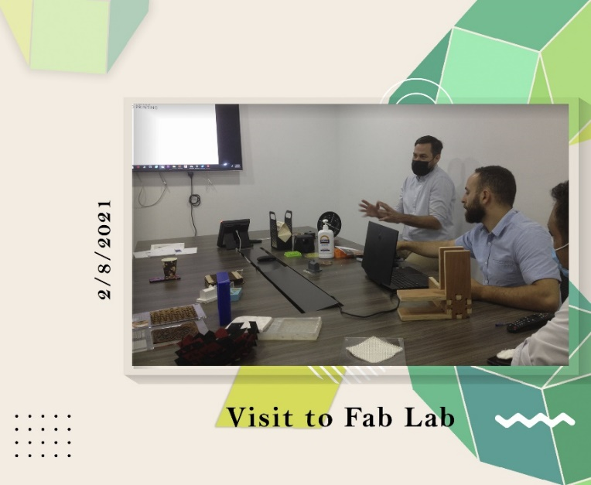
WP 8: DISSEMINATION & EXPLOITATION
Date: Monday, 2/8/2021
Organizer: Al-Zaytoonah University of Jordan
Location: HTU
The HANDS team visited the HTU Fab Lab to bridge the gap between the lab and local market needs in digital and craft fabrication. Through observation, meetings, and market analysis, the team assessed the lab's capabilities, challenges, and opportunities. Collaboration was explored between the HANDS center at ZUJ and the HTU Fab Lab, aiming to strategically align future initiatives with local market demands. This visit provided valuable insights to inform the HANDS center's development.

